**MATRIX DATA STRUCTURE**

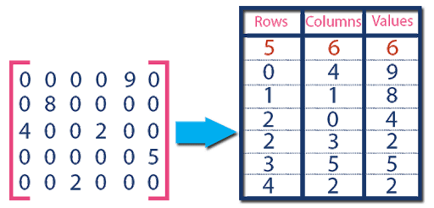

Matrix is a way to store data in an organized form in the form of rows and columns. Matrices are usually used in computer graphics to project 3-dimensional space onto a 2-dimensional screen. Matrices in the form of arrays are used to store data in an organized form.

A matrix is a representation of certain rows and columns, to persist homogeneous data. It can also be called as double-dimensioned array.  
  
Uses:  
- To represent class hierarchy using Boolean square matrix  
- For data encryption and decryption  
- To represent traffic flow and plumbing in a network  
- To implement graph theory of node representation

Real Life Example: Facebook uses matrix concept for showing mutual friends.